Add C/C++ Code To Android Project

- Create native source folder “src/main/cpp”
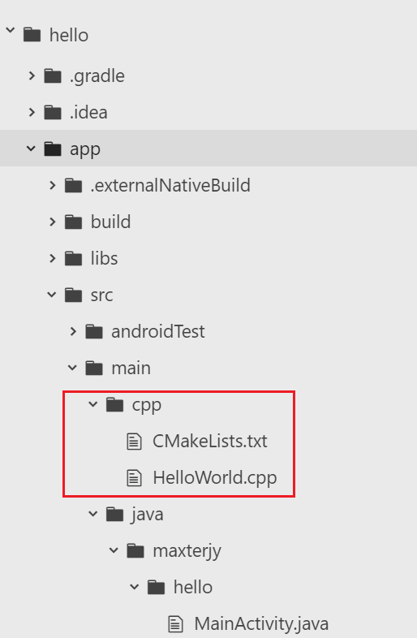

- Create native code “src/main/cpp/HelloWorld.cpp”
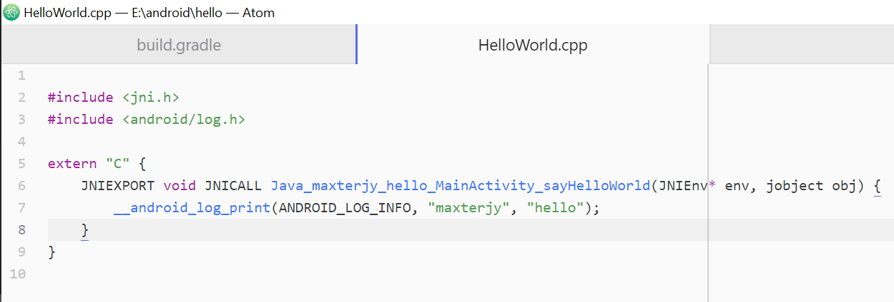

- Create cmake file “src/main/cpp/CMakeLists.txt”
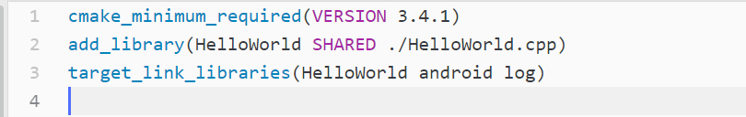

- Configure module-level gradle “app/build.gradle”
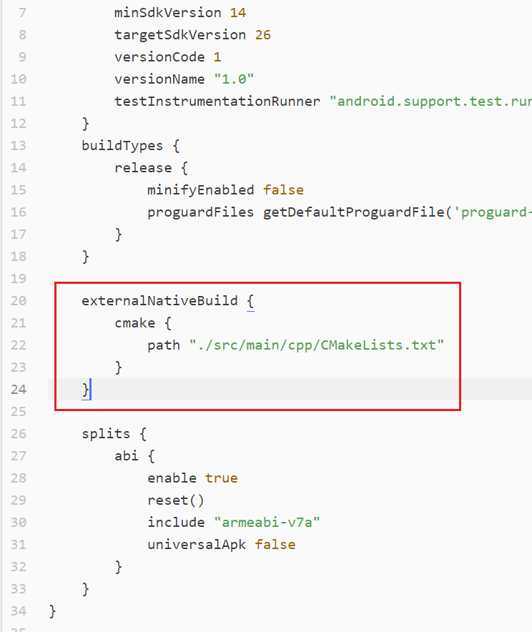

- Load library, call native function in MainActivity
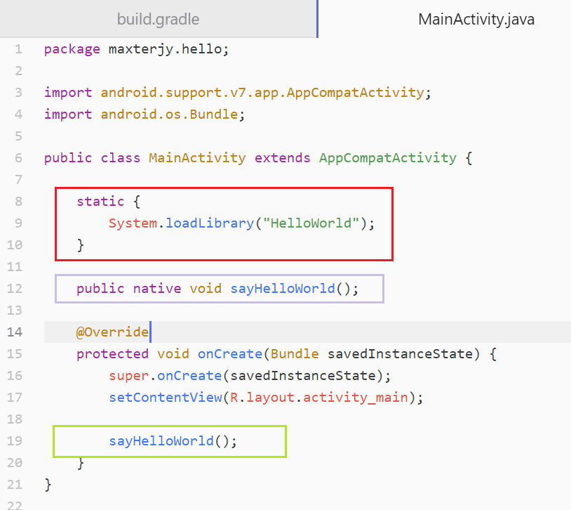

- Result
